Chapter 4

Edge to Cloud Protocol

HTTP stands for HyperText Transfer Protocol. It is invented by Tim Berner. HyperText is the type of text which is specially coded with the help of some standard coding language called HyperText Markup Language (HTML). HTTP/2 is the successor version of HTTP, which was published on May 2015. HTTP/3 is the latest version of HTTP, which is published in 2022.
The protocols that are used to transfer hypertext between two computers is known as HyperText Transfer Protocol.
HTTP provides standard between a web browser and web server to establish communication. It is set of rules for transferring data from one computer to another. Data such as text, images, and other multimedia files are shared on the World Wide Web. Whenever a web user opens their web browser, user indirectly uses HTTP. It is an application protocol which is used for distributed, collaborative, hypermdia information systems.

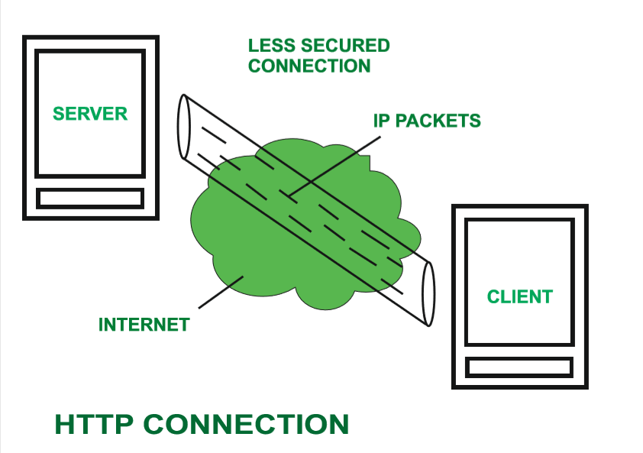

How it works ?
First of all, whenever we want to open any website then first we open web browser after that we will type URL of that website (e.g., www.facebook.com ). This URL is now sent to Domain Name Server (DNS). Then DNS first check records for this URL in their database, then DNS will return IP address to web browser corresponding to this URL. Now browser is able to sent request to actual server.
After server sends data to client, connection will be closed. If we want something else from server we should have to re-establish connection between client and server.

History ::
Tim Berners Lee and his team at CERN gets credit for inventing original HTTP and associated technologies.
- HTTP version 0.9 –This was first version of HTTP which was introduced in 1991.
- HTTP version 1.0 –In 1996, RFC 1945 (Request For Comments) was introduced in HTTP version 1.0.
- HTTP version 1.1 –In January 1997, RFC 2068 was introduced in HTTP version 1.1. Improvements and updates to HTTP version 1.1 standard were released under RFC 2616 in June 1999.
- HTTP version 2.0 –The HTTP version 2.0 specification was published as RFC 7540 on May 14, 2015.
- HTTP version 3.0 –HTTP version 3.0 is based on previous RFC draft. It is renamed as HyperText Transfer Protocol QUIC which is a transport layer network protocol developed by Google.
Characteristics of HTTP: HTTP is IP based communication protocol which is used to deliver data from server to client or vice-versa.
- Server processes a request, which is raised by client and also server and client knows each other only during current request and response period.
- Any type of content can be exchanged as long as server and client are compatible with it.
- Once data is exchanged then servers and client are no more connected with each other.
- It is a request and response protocol based on client and server requirements.
- It is connection less protocol because after connection is closed, server does not remember anything about client and client does not remember anything about server.
- It is stateless protocol because both client and server does not expecting anything from each other but they are still able to communicate.
Advantages :
- Memory usage and CPU usage are low because of less simultaneous connections.
- Since there are few TCP connections hence network congestion are less.
- Since handshaking is done at initial connection stage, then latency is reduced because there is no further need of handshaking for subsequent requests.
- The error can be reports without closing connection.
- HTTP allows HTTP pipe-lining of request or response.
Disadvantages :
- HTTP requires high power to establish communication and transfer data.
- HTTP is less secure, because it does not uses any encryption method like https use TLS to encrypt normal http requests and response.
- HTTP is not optimized for cellular phone and it is too gabby.
- HTTP does not offer genuine exchange of data because it is less secure.
- Client does not close connection until it receives complete data from server and hence server needs to wait for data completion and cannot be available for other clients during this time
https://www.geeksforgeeks.org/http-full-form/

WebSocket: WebSocket is bidirectional, a full-duplex protocol that is used in the same scenario of client-server communication, unlike HTTP it starts from ws:// or wss://. It is a stateful protocol, which means the connection between client and server will keep alive until it is terminated by either party (client or server). After closing the connection by either of the client and server, the connection is terminated from both ends.
Let’s take an example of client-server communication, there is the client which is a web browser and a server, whenever we initiate the connection between client and server, the client-server made the handshaking and decide to create a new connection and this connection will keep alive until terminated by any of them. When the connection is established and alive the communication takes place using the same connection channel until it is terminated.
This is how after client-server handshaking, the client-server decide on a new connection to keep it alive, this new connection will be known as WebSocket. Once the communication link establishment and the connection are opened, message exchange will take place in bidirectional mode until connection persists between client-server. If anyone of them (client-server) dies or decide to close the connection is closed by both of the party. The way in which socket works is slightly different from how HTTP works, the status code 101 denotes the switching protocol in WebSocket.
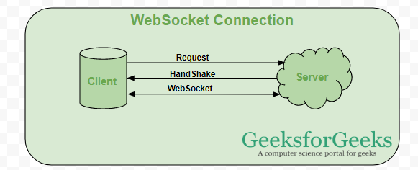
When can a web socket be used:
- Real-time web application: Real-time web application uses a web socket to show the data at the client end, which is continuously being sent by the backend server. In WebSocket, data is continuously pushed/transmitted into the same connection which is already open, that is why WebSocket is faster and improves the application performance.
For e.g. in a trading website or bitcoin trading, for displaying the price fluctuation and movement data is continuously pushed by the backend server to the client end by using a WebSocket channel.
- Gaming application: In a Gaming application, you might focus on that, data is continuously received by the server, and without refreshing the UI, it will take effect on the screen, UI gets automatically refreshed without even establishing the new connection, so it is very helpful in a Gaming application.
- Chat application: Chat applications use WebSockets to establish the connection only once for exchange, publishing, and broadcasting the message among the subscribers. It reuses the same WebSocket connection, for sending and receiving the message and for one-to-one message transfer.
When not to use WebSocket: WebSocket can be used if we want any real-time updated or continuous streams of data that are being transmitted over the network. If we want to fetch old data, or want to get the data only once to process it with an application we should go with HTTP protocol, old data which is not required very frequently or fetched only once can be queried by the simple HTTP request, so in this scenario, it’s better not use WebSocket.
Note: RESTful web services are sufficient to get the data from the server if we are loading the data only once.
Differences between HTTP and WebSocket Connection:
WebSocket Connection | HTTP Connection
WebSocket is a bidirectional communication protocol that can send the data from the client to the server or from the server to the client by reusing the established connection channel. The connection is kept alive until terminated by either the client or the server. | The HTTP protocol is a unidirectional protocol that works on top of TCP protocol which is a connection-oriented transport layer protocol, we can create the connection by using HTTP request methods after getting the response HTTP connection get closed.
Almost all the real-time applications like (trading, monitoring, notification) services use WebSocket to receive the data on a single communication channel. | Simple RESTful application uses HTTP protocol which is stateless.
All the frequently updated applications used WebSocket because it is faster than HTTP Connection. | When we do not want to retain a connection for a particular amount of time or reuse the connection for transmitting data; An HTTP connection is slower than WebSockets.
https://www.geeksforgeeks.org/what-is-web-socket-and-how-it-is-different-from-the-http/

Message Queuing Telemetry Transport (MQTT) :
It was created by Andy Standford-Clark and Arlen Nipper. It is an IoT interaction protocol based on the Publish/Subscribe model. This model is a simple model that provides support for QoS (Quality of Service). Due to its abilities, it can be found in every second IoT based device. This protocol has many features as it is over TCP and uses SSL/TLS for security. For messaging between server it uses CONNECT, PUBLISH, SUBSCRIBE, DISCONNECT, etc.

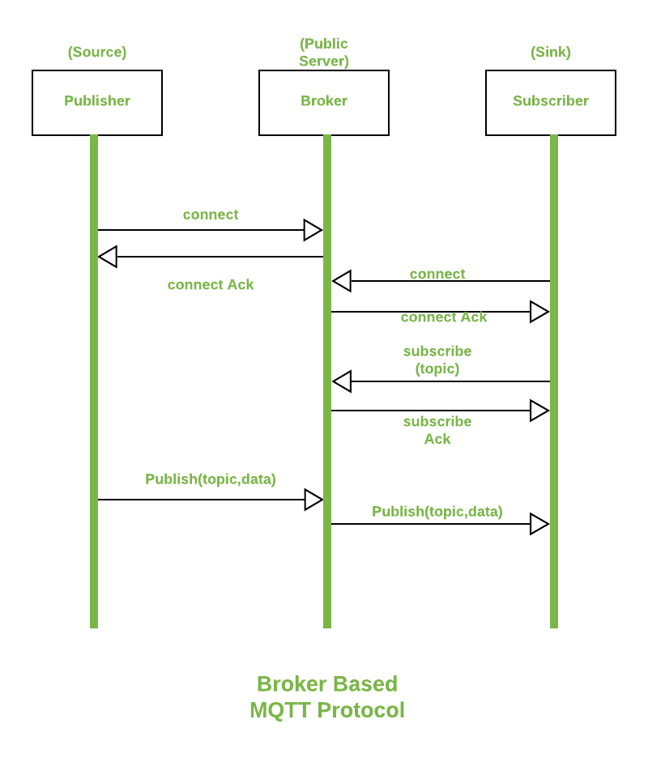

Difference between MQTT and HTTP protocols :
Parameter | MQTT | HTTP
Abbreviation | Message Queuing Telemetry Transport | Hyper Text Transfer Protocol
Architecture | It works on publish/subscribe model. | It works on request/response model.
Complexity | It has less complexity. | It is more complex.
Runs over | It runs over Transmission Control Protocol. | It runs over Transmission Control Protocol (TCP) and can also adapted to User Datagram Protocol.
Protocol Design | This protocol’s design is Data centric. | This protocol’s design is Document centric.
Message Size | The message size generated is less as it uses binary format. | The message size generated is more as it uses ASCII format.
Header Size | It is of 2 bytes. | It is of 8 bytes.
Port Number | It works on 1883 port. | It works on 80 or 8080 port.
Data Security | It provides data security with SSL/TLS. | It does not provide security but Https is built for that.

https://www.geeksforgeeks.org/difference-between-mqtt-and-http-protocols/

IoT patterns – not found

Introduction of Message Queue Telemetry Transport Protocol (MQTT)
MQTT is simple, lightweight messaging protocol used to establish communication between multiple devices. It is TCP-based protocol relying on the publish-subscribe model. This communication protocol is suitable for transmitting data between resource-constrained devices having low bandwidth and low power requirements. Hence this messaging protocol is widely used for communication in IoT Framework.
Publish-Subscribe Model :
This model involves multiple clients interacting with each other, without having any direct connection established between them. All clients communicate with other clients only via third party known as Broker.
MQTT Client and Broker :
Clients publish messages on different topics to broker. The broker is the central server that receives these messages and filters them based on their topics. It then sends these messages to respective clients that have subscribed to those different topics.
Hence client that has subscribed to a specific topic receives all messages published on that topic.
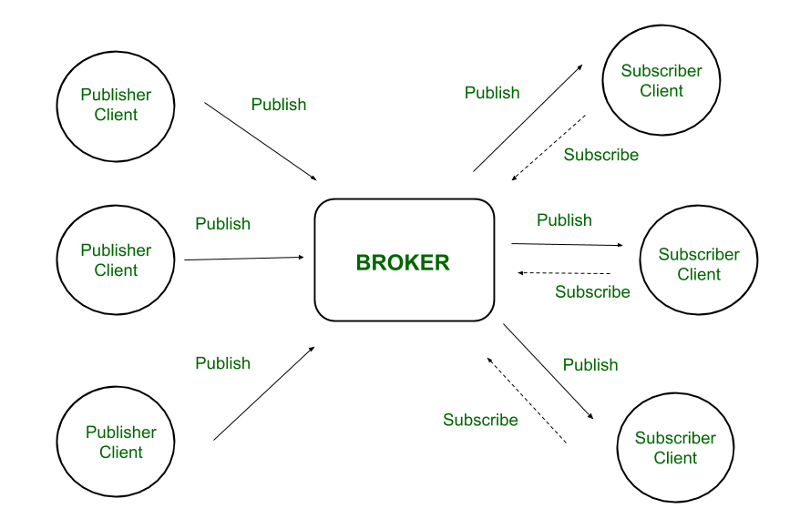
Figure – Publish-Subscribe Model
Here the broker is central hub that receives messages, filters them, and distributes them to appropriate clients, such that both message publishers, as well as subscribers, are clients.
dvantages :
- Easy Scalability –
This model is not restricted to one-to-one communication between clients. Although the publisher client sends a single message on specific topic, broker sends multiple messages to all different clients subscribed to that topic. Similarly, messages sent by multiple such publisher clients on multiple different topics will be sent to all multiple clients subscribed to those topics.
Hence one-to-many, many-to-one, as well as many-to-many communication is possible using this model. Also, clients can publish data and at the same time receive data due to this two-way communication protocol. Hence MQTT is considered to be bi-directional protocol. The default unencrypted MQTT port used for data transmission is 1883. The encrypted port for secure transmission is 8883.
- Eliminates insecure connections –
In a complex system where multiple devices are connected with each other, each device not only has to manage its connections with other devices but also has to ensure that these connections are secure. But in the publish-subscribe model, the broker becomes central server managing all security aspects. It is responsible for the authentication and authorization of all connected clients.
- Lightweight Communication –
Data transmission is quick, efficient, and lightweight because MQTT messages have small code footprint. These control messages have a fixed header of size 2 bytes and payload message up to size 256 megabytes.
https://www.geeksforgeeks.org/introduction-of-message-queue-telemetry-transport-protocol-mqtt/

MQTT and MQTT-SN are different from each other. MQTT is a protocol which is designed to be light weight for M2M, but it needs TCP/IP stack to operate. But if the sensor nodes cannot hold the TCP/IP stack then here comes MQTT-SN which does not depend on TCP/IP for it to operate.
Due to sudden increase of interest in Wireless Sensor Network (because of simplicity, low cost and easy deployment), a light weight pub-sub protocol has been developed called MQTT-SN. The SN or Sensor Network in the protocol name indicates that it is specifically designed for sensor networks. As sensor nodes are specifically made with limited processing capabilities and limited amount of storage, so these sensor nodes cannot have TCP/IP stack with themselves because TCP/IP protocol stack is too heavy to be handled by such tiny sensor nodes due to big payload, retry mechanism, time to live for the packets etc.
MQTT-SN was originally designed for running on top of the Zigbee APS layer. Any network which provides a bi-directional data transfer service between any node and a particular one (gateway) should be able to support MQTT-SN.
How MQTT-SN is different from MQTT?
First thing, MQTT-SN is designed to be as close as possible to MQTT, but is adapted to the particular behavior of wireless communication network such as low bandwidth, high link failures, short message length etc. Second, MQTT-SN is optimized for the implementation on low cost, battery-operated devices with limited processing and storage resources. Third, MQTT-SN needs a bridge to translate MQTT-SN messages into MQTT messages.
Compared to MQTT, MQTT-SN is characterized by following differences –
1) MQTT-SN supports topic ID instead of topic name. First client sends a registration request with topic name and topic ID (2 octets) to the broker. After the registration is accepted, client uses topic ID to refer the topic name. This saves media bandwidth and device memory – it is quite expensive to keep and send topic names like home/livingroom/socket2/meter in memory for each publish message.
2) The Topic name to topic ID can be preconfigured in MQTT-SN gateway, so that even registration message can be skipped before publish.
3) A discovery procedure helps clients without a pre-configured server/gateway’s address to discover the actual network address of an operating server/gateway. Multiple gateways may be present at the same time within a single wireless network and can co-operate in a load-sharing or stand-by mode.
4) The Clients connect to the broker through a gateway device, which resides within the sensor network and connects to the broker.
MQTT-SN Architecture
The architecture of MQTT-SN can be represented by the following figure –
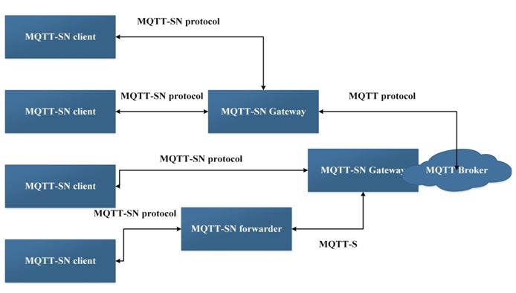
Fig. 1: Image showing MQTT-SN Architecture

There are three kinds of MQTT-SN components – MQTT-SN clients, MQTT-SN gateways (GW) and MQTT-SN forwarders. MQTT-SN clients connect themselves to a MQTT server via a MQTT-SN GW using the MQTT-SN protocol. A MQTT-SN GW may or may not be integrated with a MQTT server. In case of a stand-alone GW, the MQTT protocol is used between the MQTT server and the MQTT-SN GW. Its main function is the translation between MQTT and MQTT-SN. MQTT-SN clients can also access a GW via a forwarder in case the GW is not directly attached to their network. The forwarder simply encapsulates the MQTT-SN frames it receives on the wireless side and forwards them unchanged to the GW. In the opposite direction, it releases the frames it receives from the gateway and sends them to the clients, unchanged too.
There are two types of Gateways depending on how a Gateway performs the protocol translation between MQTT and MQTT-SN:
1) Transparent Gateway – For each MQTT-SN client, transparent gateway will form an individual MQTT connection to the MQTT broker.
2) Aggregating Gateway – In this, for all MQTT-SN clients, the Aggregating gateway will form only one MQTT connection to the MQTT broker. The advantage of using aggregating gateway is shown where WSN network has large number of sensor nodes because it helps in reducing the number of MQTT connections that broker has to create with individual client.

The MQTT-SN protocol has the following distinct features –
1) Gateway Advertisement and Discovery – A gateway continuously advertises itself by sending an ADVERTISE & GWINFO message to all devices that are part of the network. The client discovers the gateway by the Gateway unique ID. A client maintains the list of all active gateways with the network address & UID.
2) Client’s Connection Setup – An MQTT-SN client needs to setup a connection to a GW before it can exchange information with that GW.
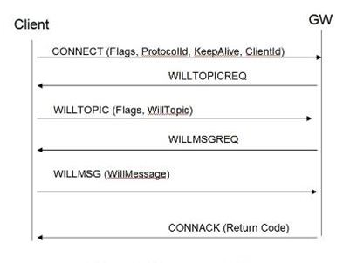
Fig. 7: Image showing MQTT-SN Client Connection Procedure
Check out the MQTT-SN specification for more details on Client connection procedure.
3) Procedure for updating the will data – The client can update the previously registered Will topic and Will message at any time by sending the WILLTOPICUPD or WILLMSGUPD message.
4) Topic Name Registration Procedure – Because of the limited bandwidth and small payload, a registration procedure is involved. The client first sends the REGISTER message with the topic name to the gateway then if GW accepts the registration, it assigns the topic ID on that topic name and acknowledge it with the REGACK message. In that way, if client sends any message to that topic, it will not use the long topic name again, it will use only the assigned 2 bytes topic ID.
5) Client Disconnect – A client sends a DISCONNECT message to the GW to indicate that it is about to close its connection. After this point, the client is then required to establish a new connection with the GW before it can exchange information with that GW again.
6) Support of Sleeping Client – The broker or server remains aware of the sleeping clients and buffer the message 0020 to deliver them when they wake up.

https://www.engineersgarage.com/mqtt-for-sensor-networks-mqtt-sn-iot-part-39/

Constrained Application Protocol (aka CoAP) is a specialized web transfer protocol for use with constrained nodes (low power sensors and actuators) and constrained networks (low power, lossy network). It enables those nodes to be able to talk with other constrained nodes over Internet. The protocol is specifically designed for M2M applications such as smart energy, home automation and many Industrial applications.
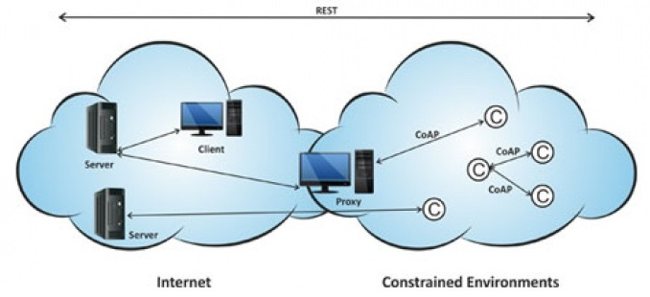
Fig. 1: Overview of CoAP Protocol for Constraint Devices
CoAP protocol is necessary because traditional protocols such as TCP/IP are considered “too heavy” for IoT applications that involves constrained devices. CoAP protocol runs on devices that support UDP protocol. In UDP protocol, client and server communicate through connectionless datagrams.
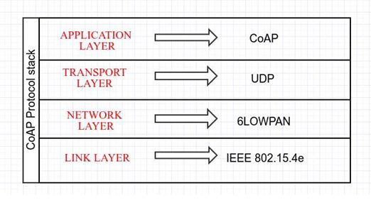
Fig. 2: Image showing CoAP Protocol Stack
As it is a web transfer protocol, it is based on RESTful architecture which provides a request/response interaction model between application endpoints and supports built-in discovery of services and resources. Like HTTP, Servers make resources under URL and clients access those resources using methods such as GET, PUT, POST and DELETE.
The CoAP protocol has the following features –
1) It provides M2M communication in constrained environment.
2) It provides security of data by datagram transportation layer security (DTLS).
3) Asynchronous message exchange.
4) Low header overhead and parsing complexity
5) URI and content type support
6) UDP binding with optional reliability supporting unicast and multicast requests.
The CoAP is different from other protocols. When compared with HTTP, CoAP is implemented for IoT and M2M environment to send messages over UDP protocol. To compensate for the unreliability of UDP protocol, CoAP defines a retransmission mechanism and provides resource discovery mechanism with resource description.
The MQTT and CoAP, both are designed to consider the long term vision that they need to be used in lightweight environments. Both works well with low power and network constrained devices. So the choice really depends on the application. If a M2M network has to be created where messages must publish from one node to multiple interested nodes, the best choice will be to use MQTT protocol. But if a M2M network has to be created where commands must be sent to among nodes, CoAP will be the best choice for that. For example to control an AC from the smart phone, CoAP would be the smarter choice.
CoAP should be on priority for the following three factors –
• Quality of service with confirmable message
• When multicast support is needed
• Very low overhead and simplicity.

https://www.engineersgarage.com/constrained-application-protocol-iot-part-32/

Basis of | COAP | MQTT
Abbreviation | Constrained Application Protocol | Message Queuing Telemetry Transport
Communication Type | It uses Request-Response model. | It uses Publish-Subscribe model
Messaging Mode | This uses both Asynchronous and Synchronous. | This uses only Asynchronous
Transport layer protocol | This mainly uses User Datagram protocol(UDP) | This mainly uses Transmission Control protocol(TCP)
Header size | It has 4 bytes sized header | It has 2 bytes sized header
RESTful based | Yes it uses REST principles | No it does not uses REST principles
Persistence support | It does not has such support | It supports and best used for live data communication
Message Labelling | It provides by adding labels to the messages. | It has no such feature.
Usability/Security | It is used in Utility area networks and has secured mechanism. | It is used in IoT applications and is secure
Effectiveness | Effectiveness in LNN is excellent. | Effectiveness in LNN is low.
Communication Model | Communication model is one-one. | Communication model is many-many.

https://www.geeksforgeeks.org/difference-between-coap-and-mqtt-protocols/

STOMP provides an interoperable wire format so that STOMP clients can communicate with any STOMP message broker to provide easy and widespread messaging interoperability among many languages, platforms and brokers.
STOMP is a very simple and easy to implement protocol, coming from the HTTP school of design; the server side may be hard to implement well, but it is very easy to write a client to get yourself connected. For example you can use Telnet to login to any STOMP broker and interact with it!

The protocol is broadly similar to HTTP, and works over TCP using the following commands:

- CONNECT
- SEND
- SUBSCRIBE
- UNSUBSCRIBE
- BEGIN
- COMMIT
- ABORT
- ACK
- NACK
- DISCONNECT
Communication between client and server is through a “frame” consisting of a number of lines. The first line contains the command, followed by headers in the form <key>: <value> (one per line), followed by a blank line and then the body content, ending in a null character. Communication between server and client is through a MESSAGE, RECEIPT or ERROR frame with a similar format of headers and body content.

https://www.thetechplatform.com/post/stomp-simple-or-streaming-text-orientated-messaging-protocol

What is Advanced Message Queuing Protocol?

The Advanced Message Queuing Protocol (AMQP) creates interoperability between clients and brokers (i.e. messaging middleware). Its goal of creation was to enable a wide range of different applications and systems to be able to work together, regardless of their internal designs, standardizing enterprise messaging on industrial scale.
AMQP includes the definitions for both the way networking takes place and the way message broker applications work. This means the specifications for:
- Operations of routing and storage of messages with the message brokers and set of rules to define how components involved work
- And a wire protocol to implement how communications between the clients and the brokers performing the above operations work

Reasons for AMQP’s Creation and Use

Before AMQP, there used to be different message brokering and transferring applications created and set in use by different vendors. However, they had one big problem and it was their lack of interoperability. There was simply not a way for one to work with another. The only method that could be used to get different systems using different protocols to work was by introducing an additional layer for converting messages called messaging bridge. These systems, using individual adapters to be able to receive messages like regular clients, would be used to connect multiple and different messaging systems (e.g. WebSphere MQ and another).
AMQP, by offering the clearly defined rules and instructions as we explained above, creates a common ground which can be used for all message queuing and brokering applications to work and interoperate.

What are AMQP Use Cases?

Whenever there is a need for high-quality and safe delivery of messages between applications and processes, AMQP implementing message brokering solutions can be considered for use.

AMQP ensures

- Reliability of message deliveries
- Rapid and ensured delivery of messages
- Message acknowledgements

These capabilities make it ideal for

- Monitoring and globally sharing updates
- Connecting different systems to talks to each other
- Allowing servers to respond to immediate requests quickly and delegate time consuming tasks for later processing
- Distributing a message to multiple recipients for consumption
- Enabling offline clients to fetch data at a later time
- Introducing fully asynchronous functionality for systems
- Increasing reliability and uptime of application deployments

AMQP Assembly and Terminology

Understanding and working with AMQP involves being familiar with quite a few different terms and terminology. In this section, we will go over these key parts:
- Broker (Server): An application - implementing the AMQP model - that accepts connections from clients for message routing, queuing etc.
- Message: Content of data transferred / routed including information such as payload and message attributes.
- Consumer: An application which receives message(s) - put by a producer - from queues.
- Producer: An application which put messages to a queue via an exchange.
Note: The payload of messages are not defined by the AMQP; various and differing types of data, therefore, can be transferred using the protocol.

Main AMQP Components

The AMQP Model defining how messages are received, routed, stored, queued and how application parts handling these tasks work rely on the clear set definitions of the below components:
- Exchange: A part of the broker (i.e. server) which receives messages and routes them to queues
- Queue (message queue): A named entity which messages are associated with and from where consumers receive them
- Bindings: Rules for distributing messages from exchanges to queues

How Do AMQP Message Brokers Work?

In AMQP, “message brokers” translate to applications which receive the actual messages and route (i.e. transfer) them to relevant parties.
APPLICATION EXCHANGE TASK LIST WORKER
[DATA] -------> [DATA] ---> [D]+[D][D][D] ---> [DATA]
Publisher EXCHANGE Queue Consumer
https://www.digitalocean.com/community/tutorials/an-advanced-message-queuing-protocol-amqp-walkthrough

